**Gogoads.lk – Comments 1**

Landing page comments

* Add banners only horizontal included no vertical
* Listing page a ads lagbe 1 ta
* need 3 banners at each page
* icon colors
* home page a carousal a two row
* need to check the slide/timing
* location Sri Lanka
* Languages English with Sinhala
* Need to do social login
* Quick link no linked
* Social media link, please include youtube

Premier ads display

* Need to differentiate with background color
* Special attention: outer box/ member/ verified need to be displayed.

Example:

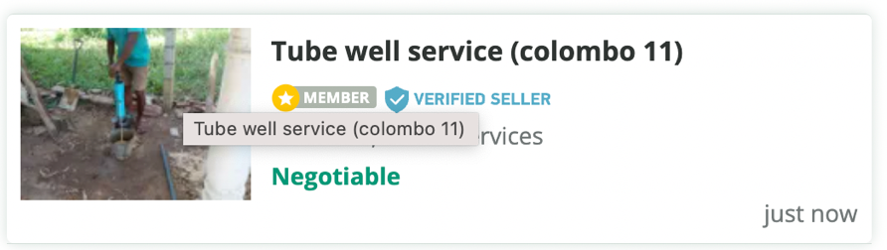

All ads:

* More ads to be displayed in vertically no slide required
* At least more than 20 ads then navigation

**< Previous 1 2 3 4 5 6 7 > Next**

* Ad banners to be placed horizontal and vertical (3 nos)

Categories

* Please follow the standard main/subcategories as per other websites, I have checked many items user to find or type (mandate to follow the standard and user-friendly system)
* Properties: need more subcategories - Land, house for sale, house for rent, apartment sale, apartment rentals, room & Annexures, Holiday & short terms rentals,
* VEHCILES please include standard features as per popular websites, user friendly system
* Following is missing

Business & Industry, Services, Hobby, Sport & Kids, Education, Agriculture

Registration

* No telephone mandate at registration: it will be mandate while posting page
* Declaration: please include a sentence at same place “By signing up for an account you agree to our [Terms and Conditions](gogoads.lk)”
* Remove the check box

Ad post

There are too many comments and not as per standard features

1. I will add another banner after location section
2. Home slider will be removed and 8 ads will be shown
3. Multi language
4. 50 ads on listing page
5. Verified customer & member
6. We will try to give 6 images
7. Banner ads on ads details page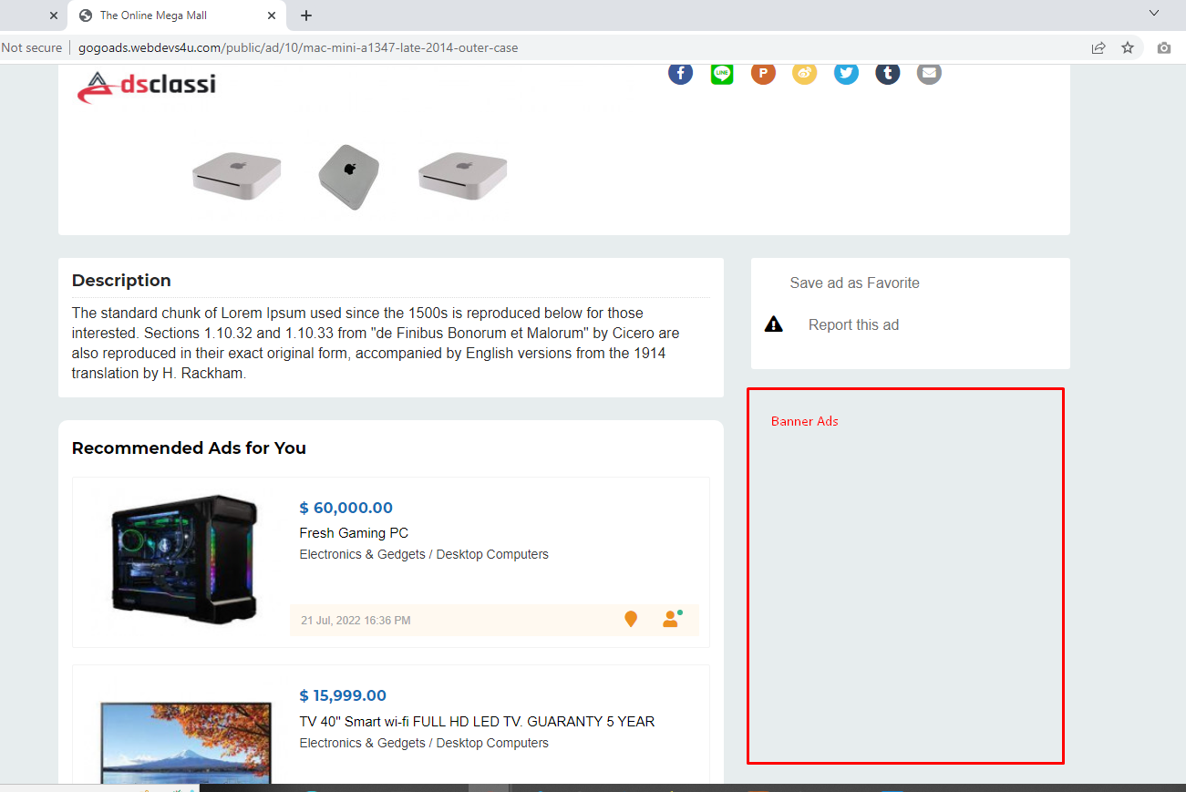
8. 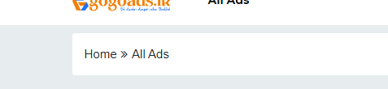ads details page breadcumb
9. Ads details shorten
10. 4 ads on recommendation
11. On registration need to remove Contact Number*
12. need to remove
13. Ads expire
14. Profile picture
15. Upgrade plan link
16. breadcumb for all pages